**Bilaspur Hackathon Report 4**

**Theme - Made in india products landing Webpage**

* **Deepika S(GSBSP-MI05)**

This is my 4th report of hackathon bilapsur .Till now I have made a Navbar and a Title section for my website. I used HTML5, CSS3,javascript and Bootstrap for making it. I have attached my snapshot of website along with the credits of images,logo ,font etc details below

**Snaphot of home page**

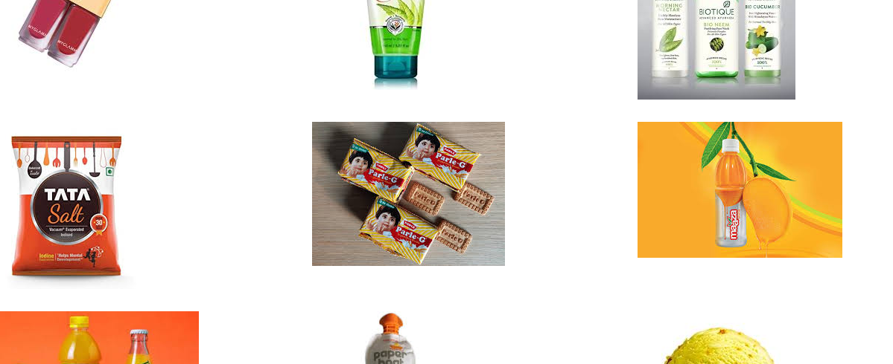

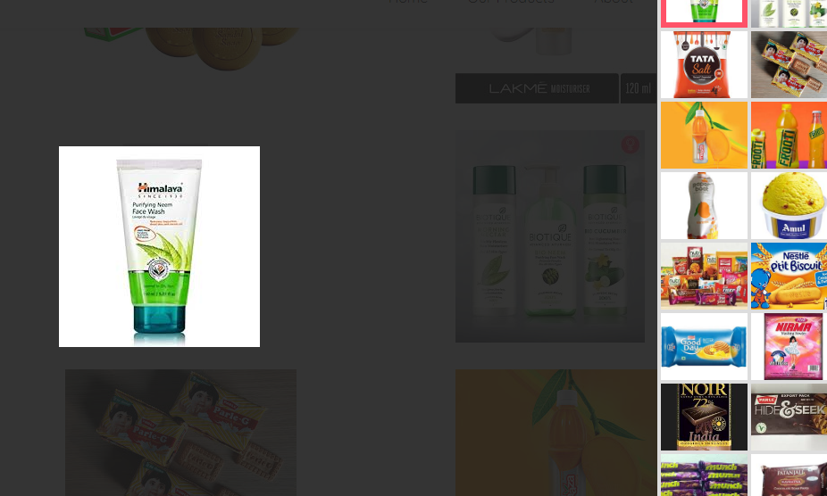

**Snapshot of code in text editor** 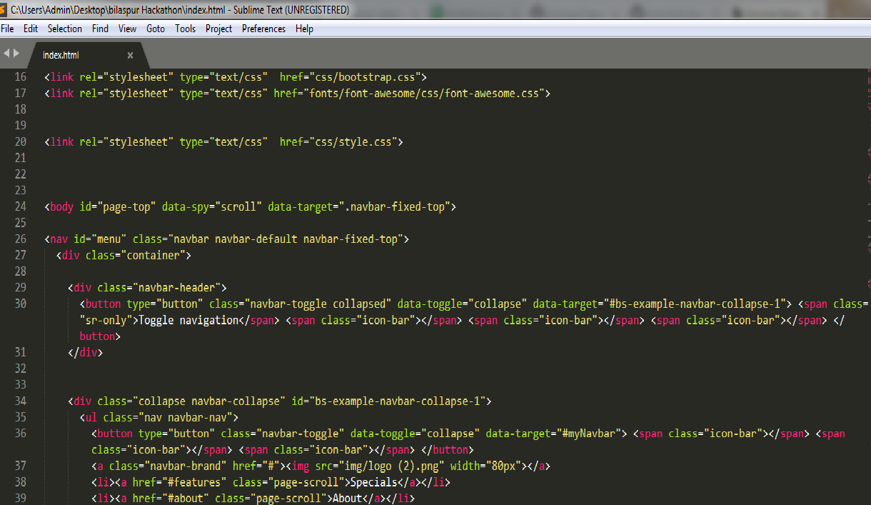

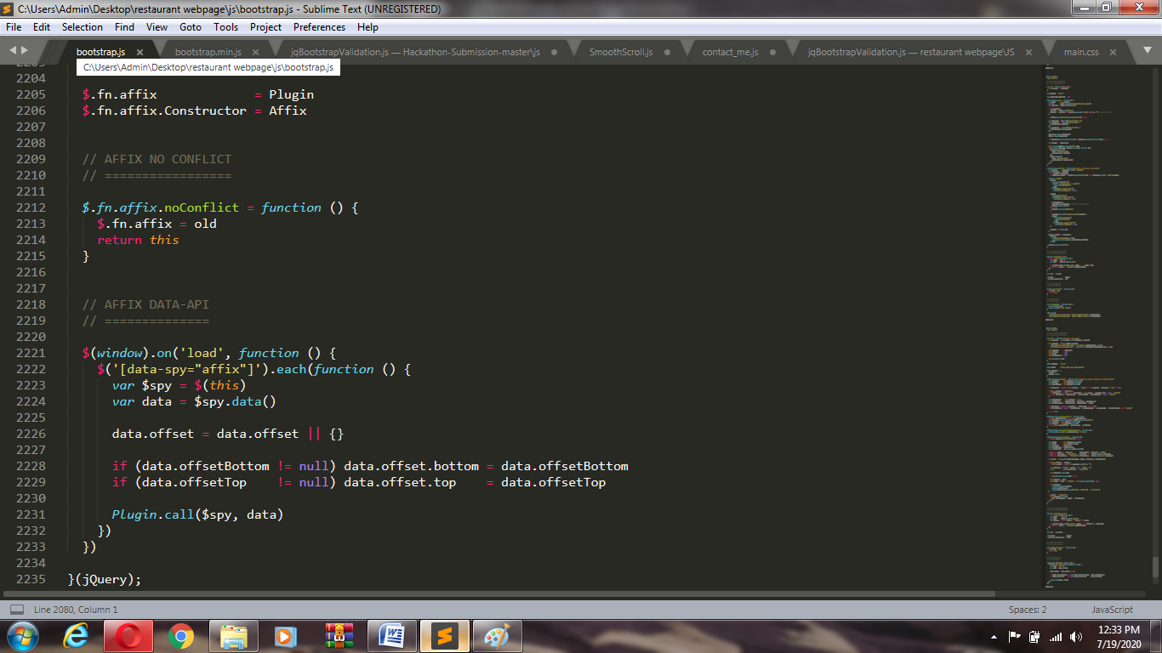

CREDITS::

Header Background Image : google image

Logo – from mobile app

Fonts from Google Fonts

Editor used : sublime